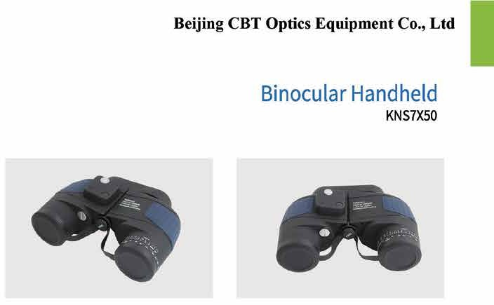

Key Features
It has Spherical lens and prism made of optical glass, multi coated optic. Fold down eyecups and made of rubber. Nitrogen purging and Makrolon housing. Waterproof: 2 hours @1.5 meters depth and also shock resistant: 1.5-meter height in sand. It also capable of range finder illuminated compass (ranging reticle with illuminated compass) and UV protection.

Field of view (at 1000m) | : 132m
Lens | : Fully multi-coated
Magnification | : 7x
Field angle | : 7°
Exit pupil diameter | : 7mm
Prism | : Porro
Eye pupil adjustment | : Yes
Body style | : Semi-aromatic thermoplastic
Objective diameter | : 50mm
Surface treatment | : Rubber
Standard | : ISO
Accessories | : Carrying case and operating manual in  English/Chinese

